Unemployment Rate Forecasting Dashboard
By: Robert McDougall, Ieuan Esteban, Justin Regidor, Phat Bui
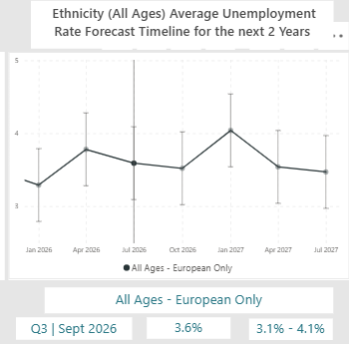
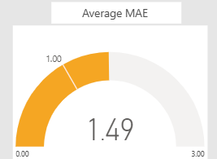
Advisor: Anjali De Silva Client: Dr. Trang Do
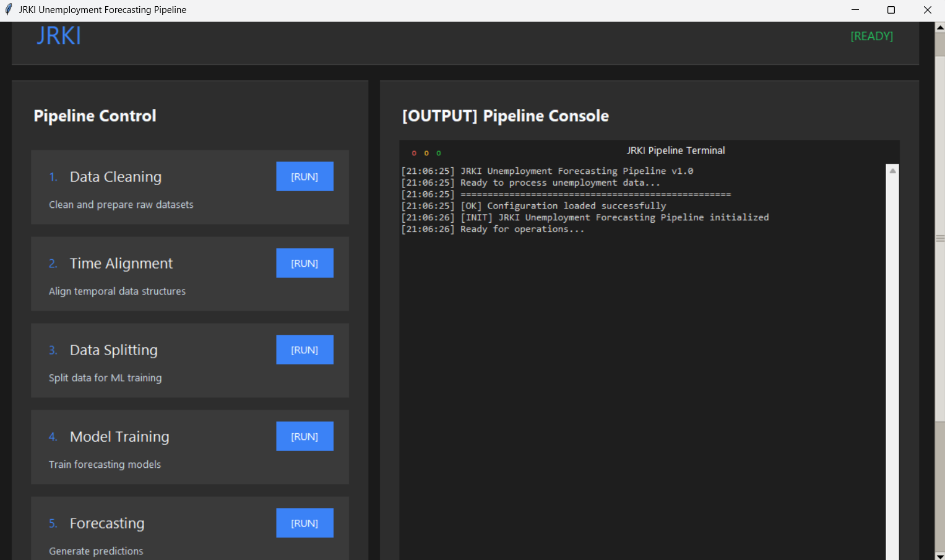
GUI Pipeline
Model Performance (MAE)
Average Unemployment Rate Forecast
INTRODUCTION
This project tackles delayed and static unemployment reporting in New Zealand by creating an interactive forecasting dashboard. With official statistics often lagging, our system delivers real time insights to support faster, more informed policy and planning decisions.
To achieve this, we have developed a Power BI dashboard integrated with machine learning forecasting models. Python processes raw data to generate accurate unemployment forecasts, visualized through dynamic and interactive charts. The blend of predictive analytics and intuitive design offers a faster and smarter alternative to static reporting.

DEVELOPMENT
The project began with problem scoping and requirement gathering to address gaps in unemployment data reporting. Clear goals of automation, timeliness and accessible insights were set with a structured timeline to stay on track.

We used a scrumban methodology that blended structured sprints with Kanban’s flexibility. This allowed fast iterations and effective feedback integration.

Power BI was chosen for its strong integration and interactive dashboard capabilities. Python

handled data processing and forecasting with ARIMA, Random Forest and Gradient Boosting models.

Testing ensured the dashboard met quality standards. Functional, usability and UAT testing verified performance, ease of use and stakeholder alignment.

Forecasting methods were guided by time series research to ensure credible results. Random Forest had delivered the best performance across demographics.

Challenges like inconsistent data and model tuning were solved through iterative testing and automated validation. The final system was faster, more reliable and accurate.
CONCLUSION
The project successfully delivered an automated unemployment rate forecasting dashboard that provides timely, accurate and visually clear insights. Our system streamlines forecasting from hours to minutes, supports dynamic data update and meets stakeholder expectations for usability and analytical depth. This outcome not only addresses the core project objectives but also lays the foundation for future applications in other economic reporting areas.

